Step 1 - Place the “case top” upside down

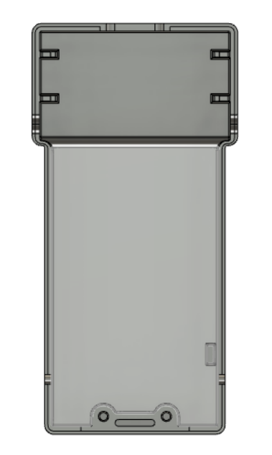

Step 2 -Stick the antenna on the case top using yellow tape

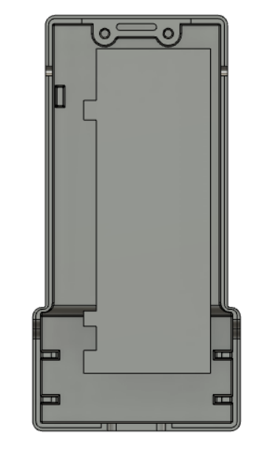

Step 4 - Place the “Case top” on top of the “Clip middle” part

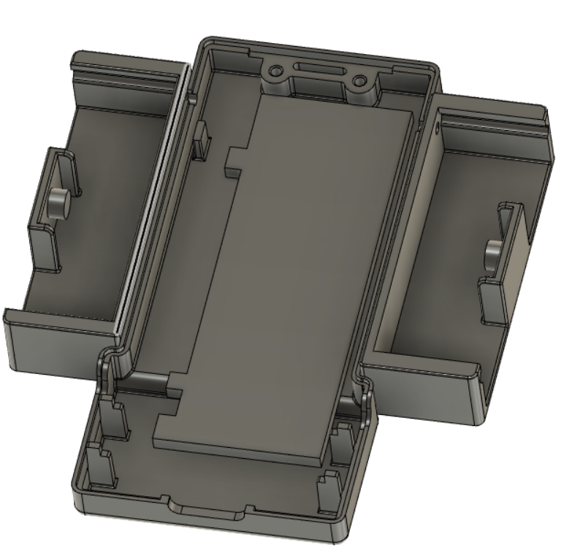

Step 5 - Fix the case top and the Clip using M1.6 8mm screws and nuts as shown in the image below.

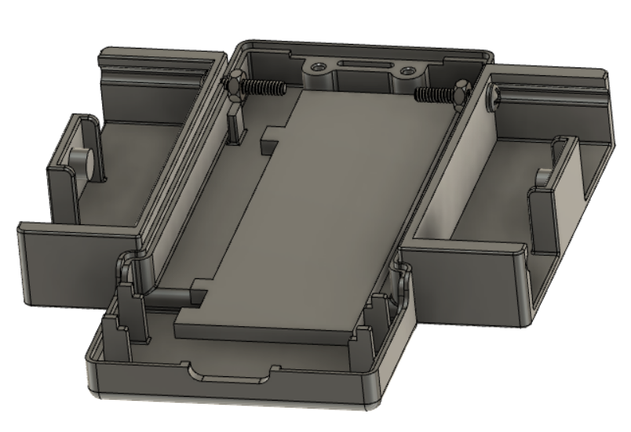

Step 7 -Place the PCB on top and connect the antenna UFL connector to the PCB

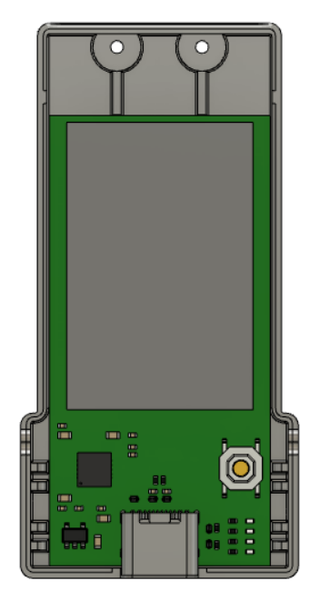

Step 8 -Put the Case bottom part and fix it with two M1.6 screws.

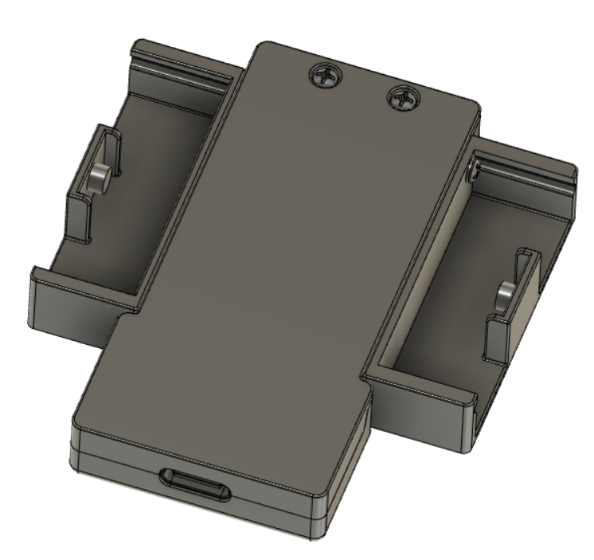

Step 9 - Push the Clip left and right part so that it snaps into the groove as shown in the image below.

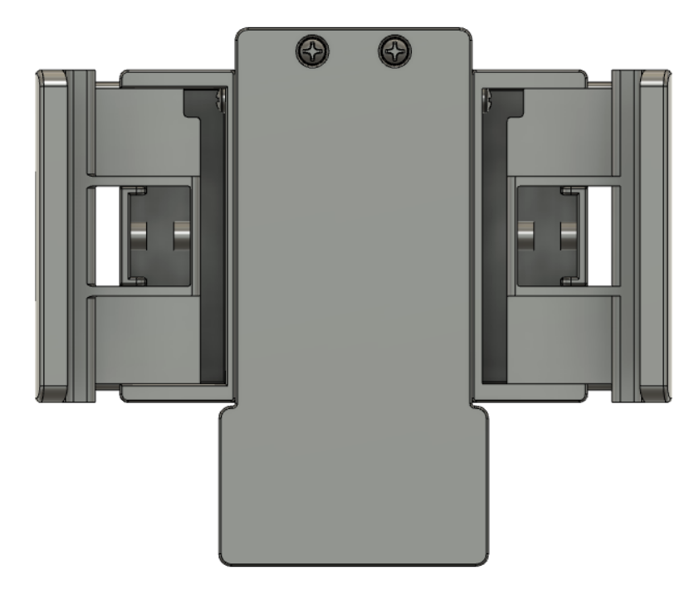

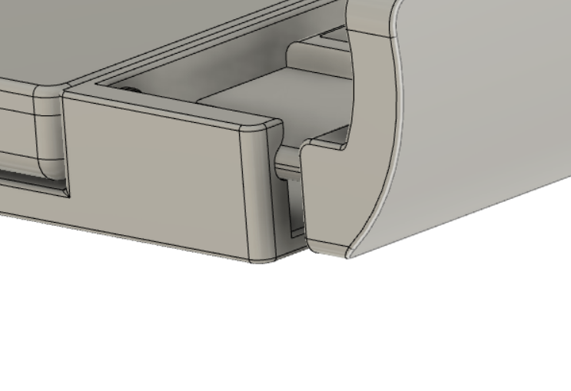

Step 10 -Push the springs inside. The cylindrical structure should be inside the spring.

